LAP 9
Tên: Nguyễn Trường Thịnh
MSSV 1150080157
TH1
SQL
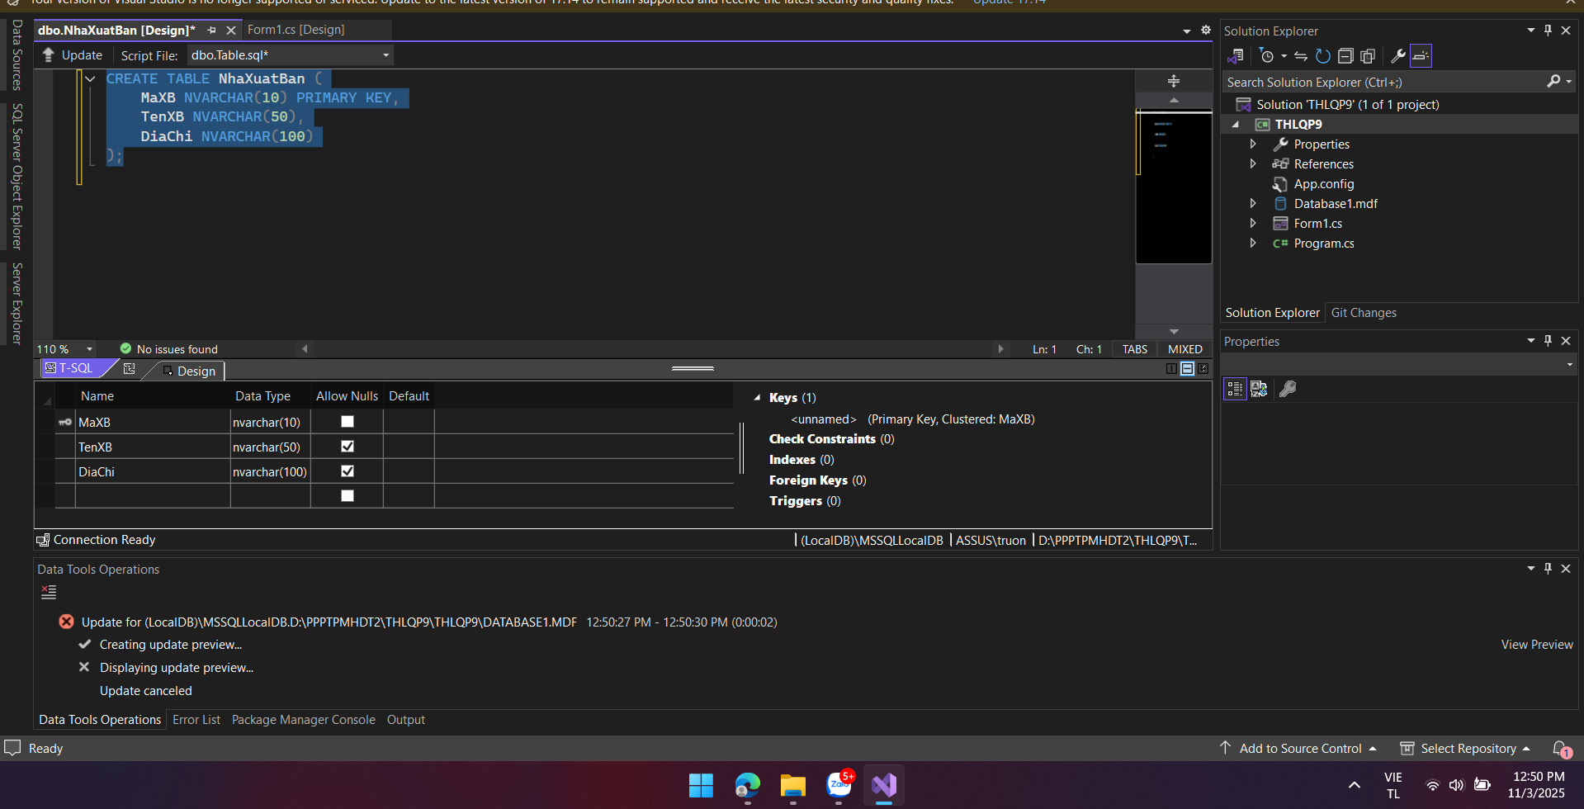

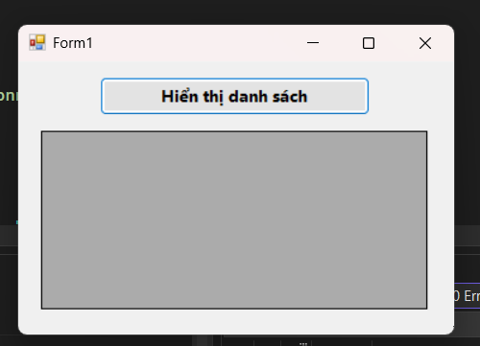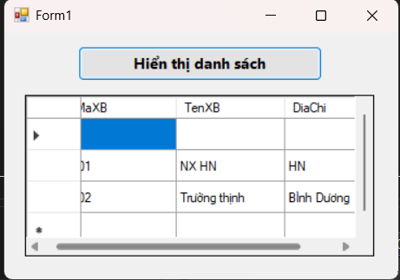

- form 1.cs
namespace THLQP9
{
partial class Form1
{
private System.ComponentModel.IContainer components = null;

protected override void Dispose(bool disposing)
{
if (disposing && (components != null))
{
components.Dispose();
}
base.Dispose(disposing);
}

#region Windows Form Designer generated code

private void InitializeComponent()
{
this.btnHienThi = new System.Windows.Forms.Button();
this.dgvDanhSach = new System.Windows.Forms.DataGridView();
((System.ComponentModel.ISupportInitialize)(this.dgvDanhSach)).BeginInit();
this.SuspendLayout();
//
// btnHienThi
//
this.btnHienThi.BackColor = System.Drawing.SystemColors.ControlLight;
this.btnHienThi.Font = new System.Drawing.Font("Segoe UI", 10F, System.Drawing.FontStyle.Bold, System.Drawing.GraphicsUnit.Point);
this.btnHienThi.Location = new System.Drawing.Point(90, 20);
this.btnHienThi.Name = "btnHienThi";
this.btnHienThi.Size = new System.Drawing.Size(300, 50);
this.btnHienThi.TabIndex = 0;
this.btnHienThi.Text = "Hiển thị danh sách";
this.btnHienThi.UseVisualStyleBackColor = false;
this.btnHienThi.Click += new System.EventHandler(this.btnHienThi_Click);
//
// dgvDanhSach
//
this.dgvDanhSach.ColumnHeadersHeightSizeMode = System.Windows.Forms.DataGridViewColumnHeadersHeightSizeMode.AutoSize;
this.dgvDanhSach.Location = new System.Drawing.Point(25, 90);
this.dgvDanhSach.Name = "dgvDanhSach";
this.dgvDanhSach.RowHeadersWidth = 51;
this.dgvDanhSach.RowTemplate.Height = 29;
this.dgvDanhSach.Size = new System.Drawing.Size(430, 230);
this.dgvDanhSach.TabIndex = 1;
//
// Form1
//
this.AutoScaleDimensions = new System.Drawing.SizeF(8F, 20F);
this.AutoScaleMode = System.Windows.Forms.AutoScaleMode.Font;
this.ClientSize = new System.Drawing.Size(484, 351);
this.Controls.Add(this.dgvDanhSach);
this.Controls.Add(this.btnHienThi);
this.Name = "Form1";
this.StartPosition = System.Windows.Forms.FormStartPosition.CenterScreen;
this.Text = "Form1";
((System.ComponentModel.ISupportInitialize)(this.dgvDanhSach)).EndInit();
this.ResumeLayout(false);
}

#endregion

private System.Windows.Forms.Button btnHienThi;
private System.Windows.Forms.DataGridView dgvDanhSach;
}
}

TH2
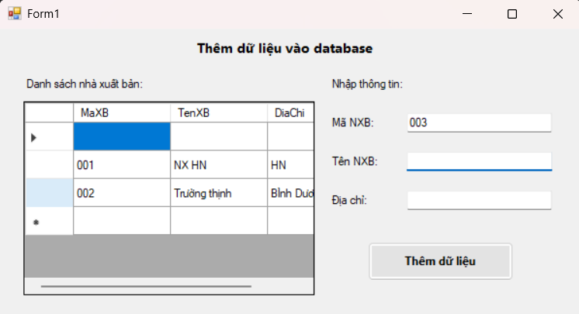
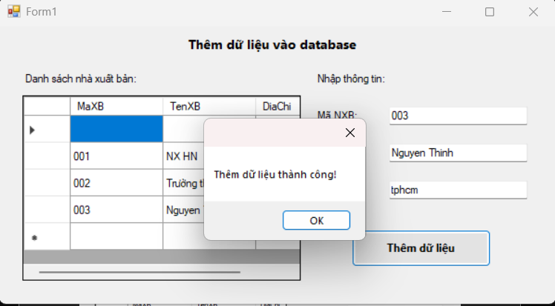
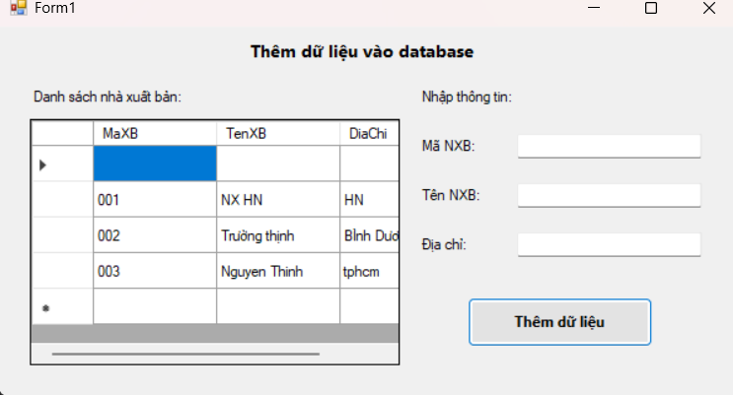
-form2.cs
namespace THLQP9
{
partial class Form2
{
private System.ComponentModel.IContainer components = null;

protected override void Dispose(bool disposing)
{
if (disposing && (components != null))
{
components.Dispose();
}
base.Dispose(disposing);
}

#region Windows Form Designer generated code

private void InitializeComponent()
{
this.labelTitle = new System.Windows.Forms.Label();
this.labelDanhSach = new System.Windows.Forms.Label();
this.labelNhapTT = new System.Windows.Forms.Label();
this.labelMaXB = new System.Windows.Forms.Label();
this.labelTenXB = new System.Windows.Forms.Label();
this.labelDiaChi = new System.Windows.Forms.Label();
this.txtMaXB = new System.Windows.Forms.TextBox();
this.txtTenXB = new System.Windows.Forms.TextBox();
this.txtDiaChi = new System.Windows.Forms.TextBox();
this.btnThem = new System.Windows.Forms.Button();
this.dgvDanhSach = new System.Windows.Forms.DataGridView();
((System.ComponentModel.ISupportInitialize)(this.dgvDanhSach)).BeginInit();
this.SuspendLayout();
//
// labelTitle
//
this.labelTitle.AutoSize = true;
this.labelTitle.Font = new System.Drawing.Font("Segoe UI", 10F, System.Drawing.FontStyle.Bold, System.Drawing.GraphicsUnit.Point);
this.labelTitle.Location = new System.Drawing.Point(200, 10);
this.labelTitle.Name = "labelTitle";
this.labelTitle.Size = new System.Drawing.Size(214, 23);
this.labelTitle.TabIndex = 0;
this.labelTitle.Text = "Thêm dữ liệu vào database";
//
// labelDanhSach
//
this.labelDanhSach.AutoSize = true;
this.labelDanhSach.Location = new System.Drawing.Point(25, 50);
this.labelDanhSach.Name = "labelDanhSach";
this.labelDanhSach.Size = new System.Drawing.Size(166, 20);
this.labelDanhSach.TabIndex = 1;
this.labelDanhSach.Text = "Danh sách nhà xuất bản:";
//
// labelNhapTT
//
this.labelNhapTT.AutoSize = true;
this.labelNhapTT.Location = new System.Drawing.Point(340, 50);
this.labelNhapTT.Name = "labelNhapTT";
this.labelNhapTT.Size = new System.Drawing.Size(115, 20);
this.labelNhapTT.TabIndex = 2;
this.labelNhapTT.Text = "Nhập thông tin:";
//
// labelMaXB
//
this.labelMaXB.AutoSize = true;
this.labelMaXB.Location = new System.Drawing.Point(340, 90);
this.labelMaXB.Name = "labelMaXB";
this.labelMaXB.Size = new System.Drawing.Size(63, 20);
this.labelMaXB.TabIndex = 3;
this.labelMaXB.Text = "Mã NXB:";
//
// labelTenXB
//
this.labelTenXB.AutoSize = true;
this.labelTenXB.Location = new System.Drawing.Point(340, 130);
this.labelTenXB.Name = "labelTenXB";
this.labelTenXB.Size = new System.Drawing.Size(68, 20);
this.labelTenXB.TabIndex = 4;
this.labelTenXB.Text = "Tên NXB:";
//
// labelDiaChi
//
this.labelDiaChi.AutoSize = true;
this.labelDiaChi.Location = new System.Drawing.Point(340, 170);
this.labelDiaChi.Name = "labelDiaChi";
this.labelDiaChi.Size = new System.Drawing.Size(56, 20);
this.labelDiaChi.TabIndex = 5;
this.labelDiaChi.Text = "Địa chỉ:";
//
// txtMaXB
//
this.txtMaXB.Location = new System.Drawing.Point(420, 87);
this.txtMaXB.Name = "txtMaXB";
this.txtMaXB.Size = new System.Drawing.Size(150, 27);
this.txtMaXB.TabIndex = 6;
//
// txtTenXB
//
this.txtTenXB.Location = new System.Drawing.Point(420, 127);
this.txtTenXB.Name = "txtTenXB";
this.txtTenXB.Size = new System.Drawing.Size(150, 27);
this.txtTenXB.TabIndex = 7;
//
// txtDiaChi
//
this.txtDiaChi.Location = new System.Drawing.Point(420, 167);
this.txtDiaChi.Name = "txtDiaChi";
this.txtDiaChi.Size = new System.Drawing.Size(150, 27);
this.txtDiaChi.TabIndex = 8;
//
// btnThem
//
this.btnThem.BackColor = System.Drawing.SystemColors.ControlLight;
this.btnThem.Font = new System.Drawing.Font("Segoe UI", 9F, System.Drawing.FontStyle.Bold, System.Drawing.GraphicsUnit.Point);
this.btnThem.Location = new System.Drawing.Point(380, 220);
this.btnThem.Name = "btnThem";
this.btnThem.Size = new System.Drawing.Size(150, 40);
this.btnThem.TabIndex = 9;
this.btnThem.Text = "Thêm dữ liệu";
this.btnThem.UseVisualStyleBackColor = false;
this.btnThem.Click += new System.EventHandler(this.btnThem_Click);
//
// dgvDanhSach
//
this.dgvDanhSach.ColumnHeadersHeightSizeMode = System.Windows.Forms.DataGridViewColumnHeadersHeightSizeMode.AutoSize;
this.dgvDanhSach.Location = new System.Drawing.Point(25, 75);
this.dgvDanhSach.Name = "dgvDanhSach";
this.dgvDanhSach.RowHeadersWidth = 51;
this.dgvDanhSach.RowTemplate.Height = 29;
this.dgvDanhSach.Size = new System.Drawing.Size(300, 200);
this.dgvDanhSach.TabIndex = 10;
//
// Form1
//
this.ClientSize = new System.Drawing.Size(600, 300);
this.Controls.Add(this.dgvDanhSach);
this.Controls.Add(this.btnThem);
this.Controls.Add(this.txtDiaChi);
this.Controls.Add(this.txtTenXB);
this.Controls.Add(this.txtMaXB);
this.Controls.Add(this.labelDiaChi);
this.Controls.Add(this.labelTenXB);
this.Controls.Add(this.labelMaXB);
this.Controls.Add(this.labelNhapTT);
this.Controls.Add(this.labelDanhSach);
this.Controls.Add(this.labelTitle);
this.Name = "Form1";
this.StartPosition = System.Windows.Forms.FormStartPosition.CenterScreen;
this.Text = "Form1";
((System.ComponentModel.ISupportInitialize)(this.dgvDanhSach)).EndInit();
this.ResumeLayout(false);
this.PerformLayout();
}

#endregion

private System.Windows.Forms.Label labelTitle;
private System.Windows.Forms.Label labelDanhSach;
private System.Windows.Forms.Label labelNhapTT;
private System.Windows.Forms.Label labelMaXB;
private System.Windows.Forms.Label labelTenXB;
private System.Windows.Forms.Label labelDiaChi;
private System.Windows.Forms.TextBox txtMaXB;
private System.Windows.Forms.TextBox txtTenXB;
private System.Windows.Forms.TextBox txtDiaChi;
private System.Windows.Forms.Button btnThem;
private System.Windows.Forms.DataGridView dgvDanhSach;
}
}

TH3

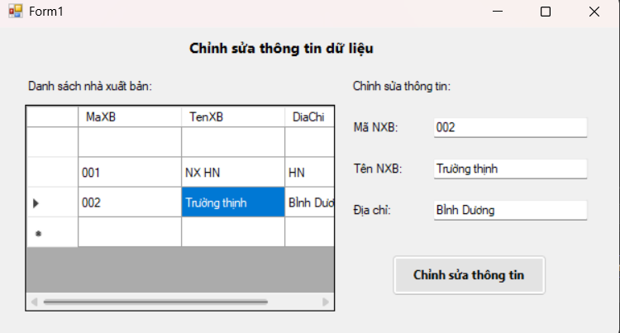
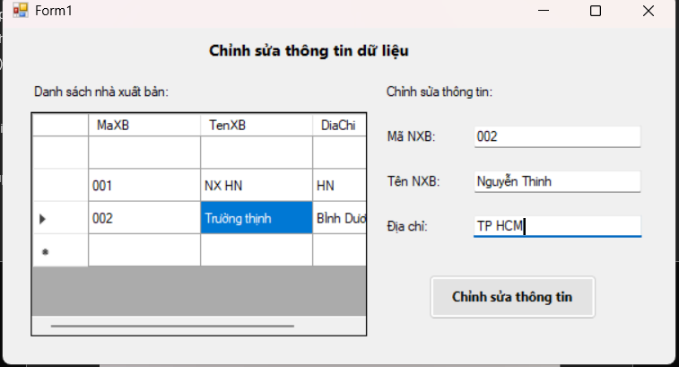
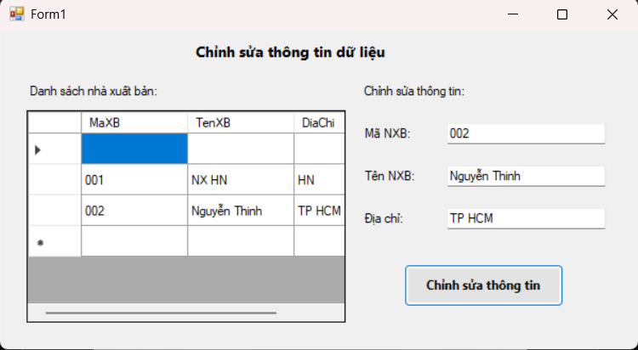
-form3.cs
using System;
using System.Data;
using System.Data.SqlClient;
using System.Windows.Forms;

namespace THLQP9
{
public partial class Form3 : Form
{
SqlConnection sqlCon = null;
SqlDataAdapter adapter = null;
DataSet ds = null;
int vt = -1; // vị trí dòng được chọn

string strCon = @"Data Source=(LocalDB)\MSSQLLocalDB;
AttachDbFilename=|DataDirectory|\Database1.mdf;
Integrated Security=True";

public Form3()
{
InitializeComponent();
HienThiDuLieu();
}

// Mở kết nối
private void MoKetNoi()
{
if (sqlCon == null)
sqlCon = new SqlConnection(strCon);
if (sqlCon.State == ConnectionState.Closed)
sqlCon.Open();
}

// Đóng kết nối
private void DongKetNoi()
{
if (sqlCon != null && sqlCon.State == ConnectionState.Open)
sqlCon.Close();
}

// Hiển thị dữ liệu
private void HienThiDuLieu()
{
try
{
MoKetNoi();
string query = "SELECT * FROM NhaXuatBan";
adapter = new SqlDataAdapter(query, sqlCon);
SqlCommandBuilder builder = new SqlCommandBuilder(adapter);

ds = new DataSet();
adapter.Fill(ds, "tblNhaXuatBan");
dgvDanhSach.DataSource = ds.Tables["tblNhaXuatBan"];
}
catch (Exception ex)
{
MessageBox.Show("Lỗi hiển thị dữ liệu: " + ex.Message);
}
finally
{
DongKetNoi();
}
}

// Khi click chọn 1 dòng trong DataGridView
private void dgvDanhSach_CellClick(object sender, DataGridViewCellEventArgs e)
{
vt = e.RowIndex;
if (vt == -1) return;

DataRow row = ds.Tables["tblNhaXuatBan"].Rows[vt];
txtMaXB.Text = row["MaXB"].ToString();
txtTenXB.Text = row["TenXB"].ToString();
txtDiaChi.Text = row["DiaChi"].ToString();
}

// Chỉnh sửa thông tin
private void btnChinhSua_Click(object sender, EventArgs e)
{
try
{
if (vt == -1)
{
MessageBox.Show("Vui lòng chọn dòng cần chỉnh sửa!");
return;
}

DataRow row = ds.Tables["tblNhaXuatBan"].Rows[vt];
row.BeginEdit();
row["MaXB"] = txtMaXB.Text.Trim();
row["TenXB"] = txtTenXB.Text.Trim();
row["DiaChi"] = txtDiaChi.Text.Trim();
row.EndEdit();

int kq = adapter.Update(ds.Tables["tblNhaXuatBan"]);
if (kq > 0)
{
MessageBox.Show("Chỉnh sửa dữ liệu thành công!");
HienThiDuLieu();
}
else
{
MessageBox.Show("Không thể cập nhật dữ liệu!");
}
}
catch (Exception ex)
{
MessageBox.Show("Lỗi khi chỉnh sửa: " + ex.Message);
}
}
}
}

-TH4
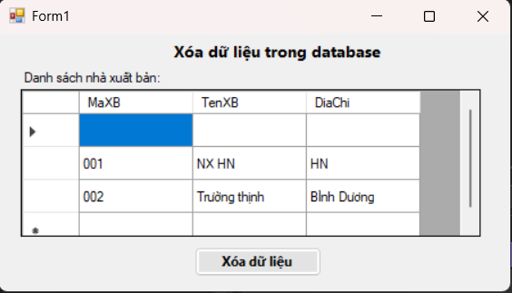
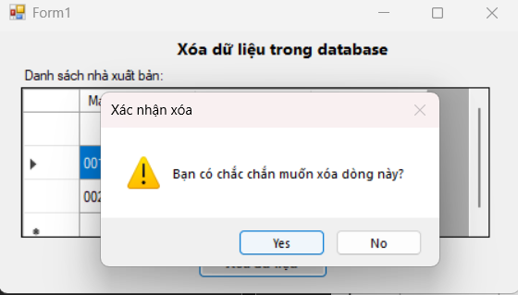
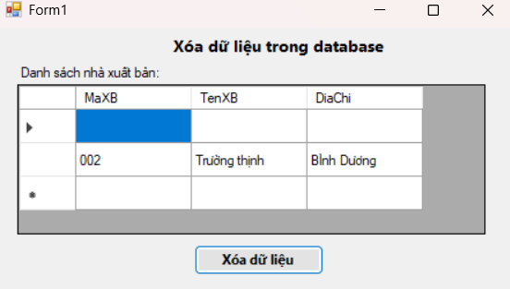
--form4.cs
using System;
using System.Data;
using System.Data.SqlClient;
using System.Windows.Forms;

namespace THLQP9
{
public partial class Form4 : Form
{
SqlConnection sqlCon = null;
SqlDataAdapter adapter = null;
DataSet ds = null;
int vt = -1; // Lưu vị trí dòng đang chọn

string strCon = @"Data Source=(LocalDB)\MSSQLLocalDB;
AttachDbFilename=|DataDirectory|\Database1.mdf;
Integrated Security=True";

public Form4()
{
InitializeComponent();
HienThiDuLieu();
}

// Hàm mở kết nối
private void MoKetNoi()
{
if (sqlCon == null)
sqlCon = new SqlConnection(strCon);
if (sqlCon.State == ConnectionState.Closed)
sqlCon.Open();
}

// Hàm đóng kết nối
private void DongKetNoi()
{
if (sqlCon != null && sqlCon.State == ConnectionState.Open)
sqlCon.Close();
}

// Hàm hiển thị dữ liệu lên DataGridView
private void HienThiDuLieu()
{
try
{
MoKetNoi();
string query = "SELECT * FROM NhaXuatBan";
adapter = new SqlDataAdapter(query, sqlCon);
SqlCommandBuilder builder = new SqlCommandBuilder(adapter);
ds = new DataSet();
adapter.Fill(ds, "tblNhaXuatBan");
dgvDanhSach.DataSource = ds.Tables["tblNhaXuatBan"];
}
catch (Exception ex)
{
MessageBox.Show("Lỗi khi hiển thị dữ liệu: " + ex.Message);
}
finally
{
DongKetNoi();
}
}

// Khi chọn 1 dòng trong DataGridView
private void dgvDanhSach_CellClick(object sender, DataGridViewCellEventArgs e)
{
vt = e.RowIndex;
}

// Xử lý nút "Xóa dữ liệu"
private void btnXoa_Click(object sender, EventArgs e)
{
if (vt == -1)
{
MessageBox.Show("Vui lòng chọn dòng cần xóa!");
return;
}

DialogResult result = MessageBox.Show("Bạn có chắc chắn muốn xóa dòng này?",
"Xác nhận xóa",
MessageBoxButtons.YesNo,
MessageBoxIcon.Warning);

if (result == DialogResult.Yes)
{
try
{
DataRow row = ds.Tables["tblNhaXuatBan"].Rows[vt];
row.Delete();

int kq = adapter.Update(ds.Tables["tblNhaXuatBan"]);
if (kq > 0)
{
MessageBox.Show("Xóa dữ liệu thành công!");
HienThiDuLieu();
vt = -1;
}
else
{
MessageBox.Show("Không thể xóa dữ liệu!");
}
}
catch (Exception ex)
{
MessageBox.Show("Lỗi khi xóa dữ liệu: " + ex.Message);
}
}
}
}
}

